Dayton Flores & Mark Sherman

ECEN 5803-401

6/23/22

Project 1 – Module 1

1. The memory usage for ***Code1Nucleo*** (assembly implementation) is 3.59 kB while the memory usage for ***M1String*** (C implementation) is 3.60 kB. From this analysis we can see that the C implementation uses 12 more bytes.

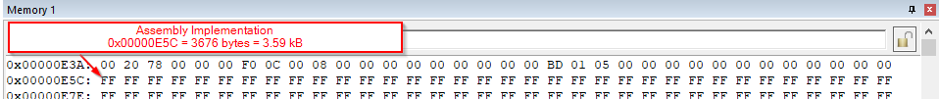

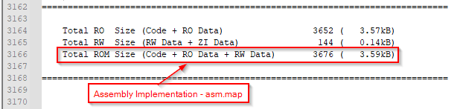

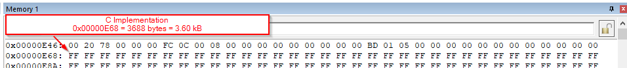

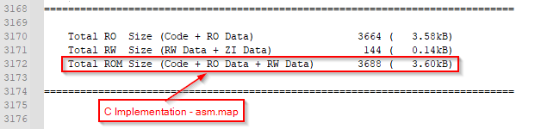

1. In the System Address Map image below:
   * Code Memory (FLASH) block has a capacity of 512 MB (0x00000000 – 0x1FFFFFFF). This is where all of the source code will be stored along with static data (constants) and the Interrupt Vector Table (which holds IRQs)
   * Data Memory (SRAM) block has a capacity of 512 MB (0x20000000 – 0x3FFFFFFF) and is the on-chip RAM. This is where dynamic data will be stored (stack and heap).
   * Peripheral Memory block has a capacity of 512 MB (0x40000000 – 0x5FFFFFFF) and is the on-chip peripheral space

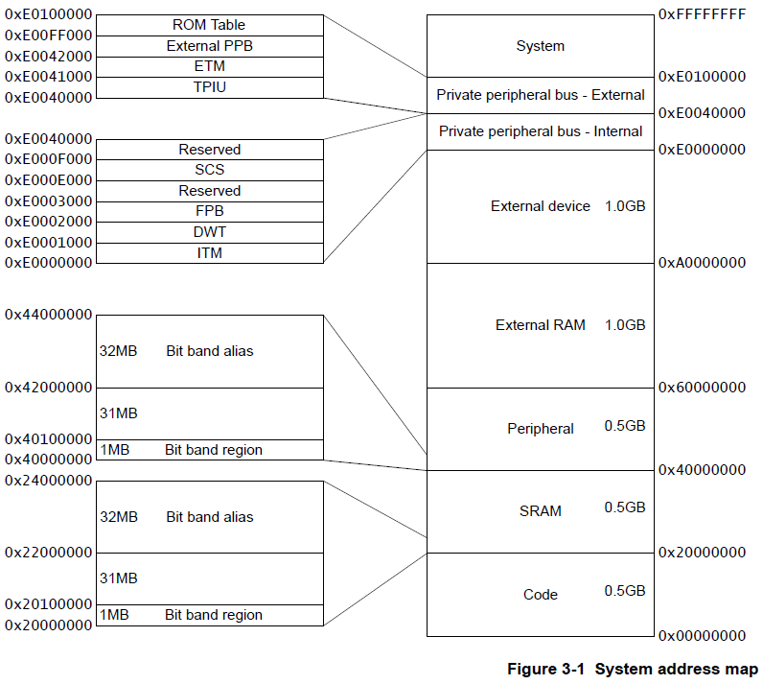

1. See below:

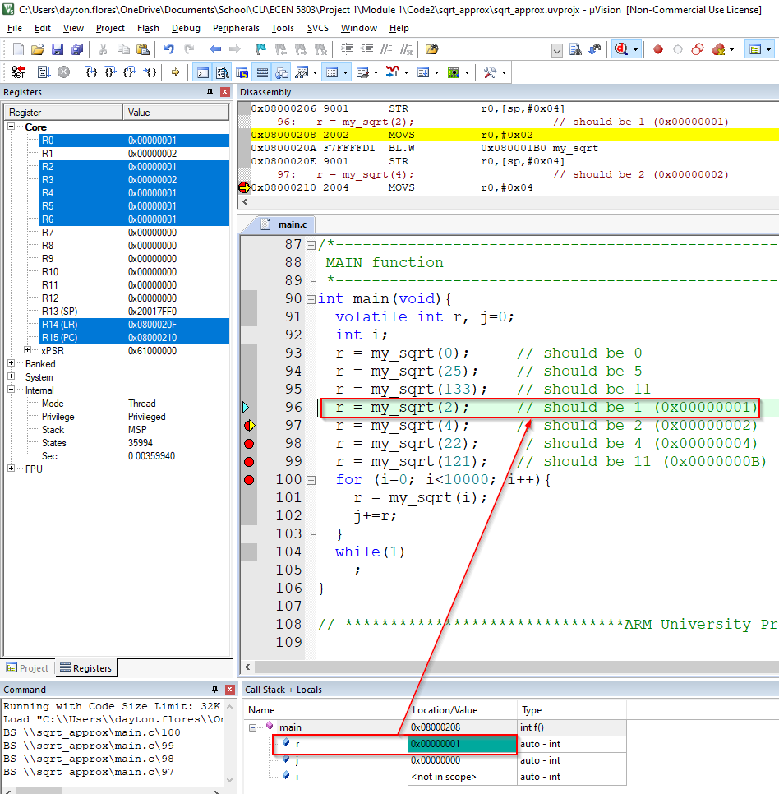

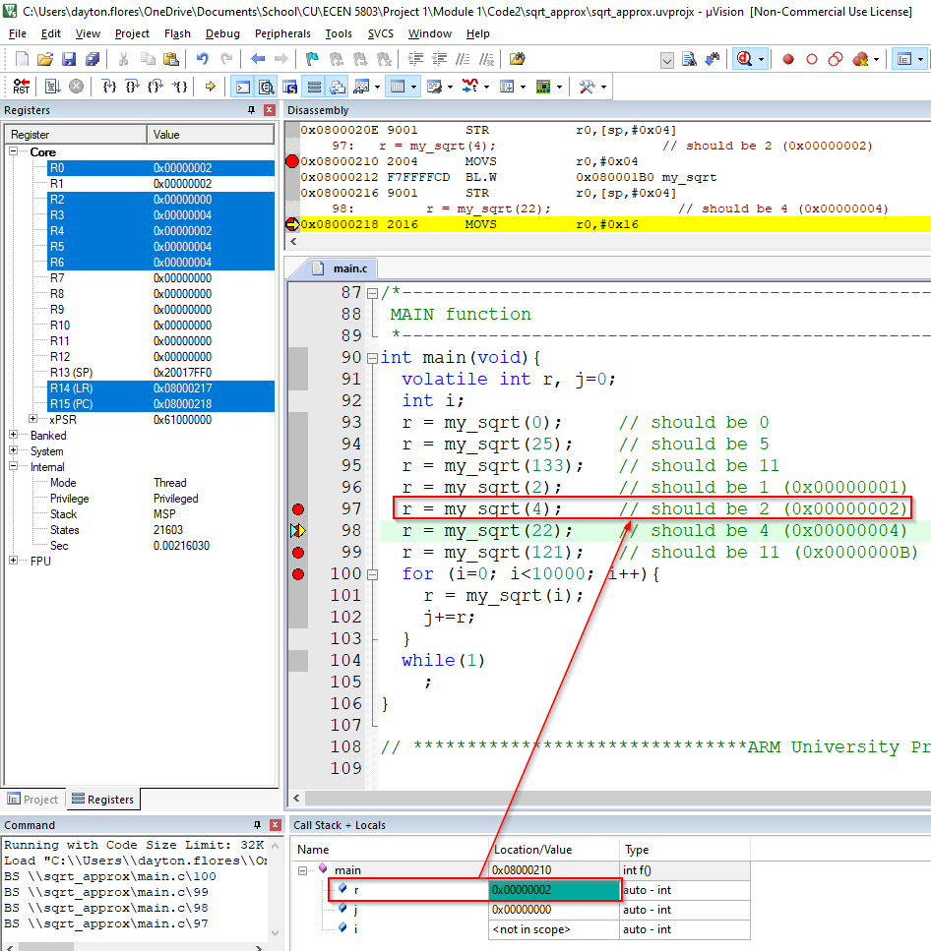

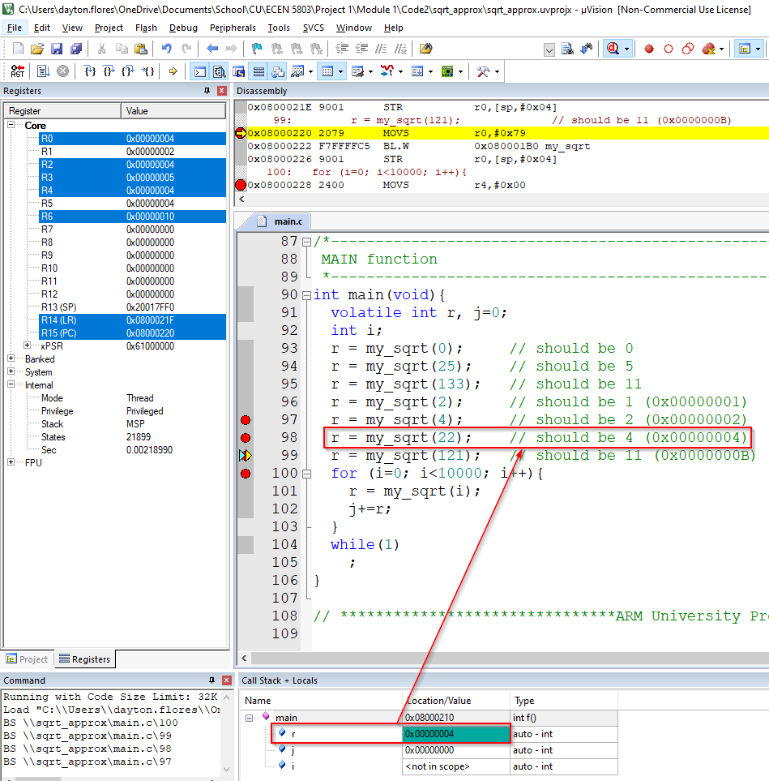

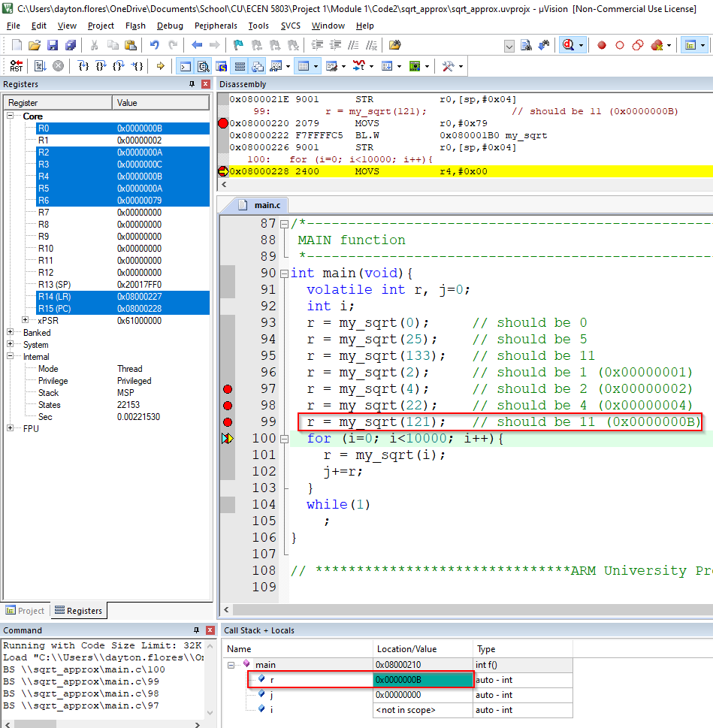

1. I set breakpoints at the beginning and end of my_sqrt() function. Then I just took the difference of ***Internal > Sec*** under the ***Registers*** panel for each test value of x.

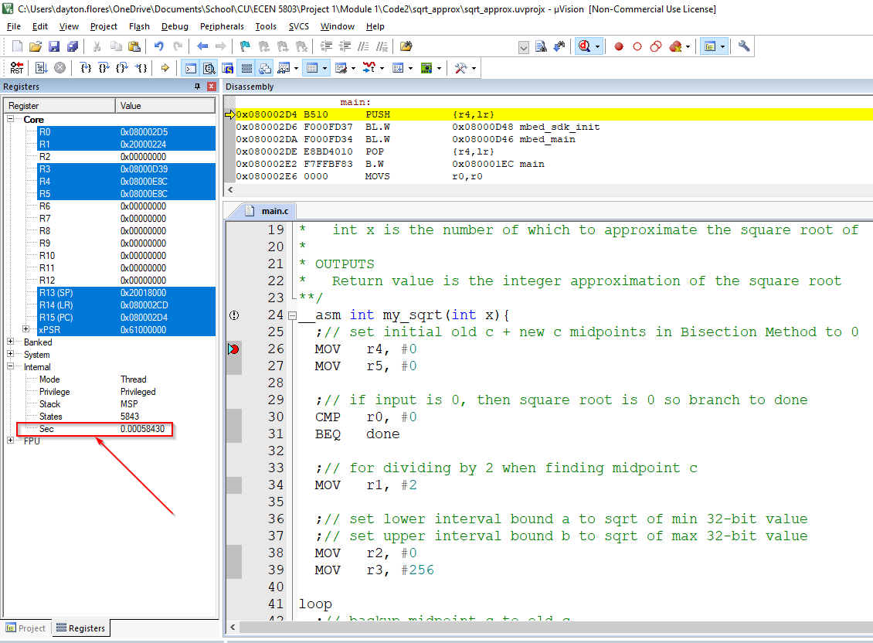

|  |  |  |  |
| --- | --- | --- | --- |
| **Function Call** | **Time to Execute (μs)** | **Frequency (MHz)** | **CPU Cycles** |
| my_sqrt(0) | 10.7 | 84 | 899 |
| my_sqrt(25) | 25.0 | 84 | 2100 |
| my_sqrt(133) | 27.6 | 84 | 2319 |
| my_sqrt(2) | 27.3 | 84 | 2294 |
| my_sqrt(4) | 23.0 | 84 | 1932 |
| my_sqrt(22) | 29.3 | 84 | 2462 |
| my_sqrt(121) | 24.9 | 84 | 2092 |

1. See ***..\Code2\ sqrt_approx\Doxygen*** in the ZIP